**YJ-APS-1313L-G01**

**Chip-on-board LED**

**StandardWhite**

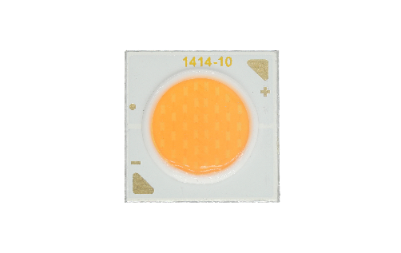

**Applications**

- High-end architectural lighting

- Healthy lighting

- Photoelectric device and relevant research

**YUJILEDS®APS series LED datasheet**

**Features**

- 99% similarity to the sunlight spectrum

- Industrial high CRI performance

- 10W power consumption

- 13.5 mm × 13.5 mm chip-on-board LED

- Ф8.4mm LES (Light-Emitting Surface)

- TLCI & TM-30 specified

- SimpleBinning solution

**About Yujileds®**

Rev Version: 2.0

P3220037.00

**Table of Contents**

General description 3

Ordering information 8

Characteristics 9

Electrical-optical characteristics (TA = 25°C, 300mA) 9

Absolute maximum ratings (TA = 25°C) 10

Chromaticity group and diagram 11

Chromaticity bins & coordinates 11

CIE 1931 diagram 11

Package material and dimension 12

Package layout 12

Package materials 12

Characteristic graph 13

Typical spectral power distribution (normalized) 13

Forward current 14

Vs. forward voltage 14

Vs. relative luminous flux 14

Vs. relative chromaticity shift 15

Vs. absolute chromaticity shift 15

Derating based on solder point 16

Solder point temperature (Ts) 17

Vs. forward voltage 17

Vs. relative luminous flux 17

Vs. relative chromaticity shift 18

Spatial distribution (TA = 25°C, IF = 100 mA) 18

About Yujileds 19

# General description

The APS series LED is designed for creating a new era of natural lighting spectrum LED with superb color rendering performance. Improving the artificial lighting as close to the sunlight is the eternal pursuit for the top LED manufacturers. However, the artificial lighting gets far away from the naturalness after the incandescent and halogen because the illumination principles of the later artificial lights are far away from the blackbody radiation, including LED.

The sun essentially provides complete and homogenous spectral radiation in the visual wavelengths, while an LED is always combined by the blue or purple semiconductor die with blue/green/amber/red phosphors, in consequence, it is visualized to observe that from an LED spectrum, peaks and gaps always exist because of the respective characteristics of the die and phosphors, which can not be avoided generally.

## 99% similarity to the sunlight spectrum

**450nm**

**700nm**

**The sun spectrum at 1:00 pm.**

**Yujileds® APS series spectrum.**

**The standard LED spectrum.**

Yujileds® APS series LED is based on innovative and revolutionary technologies. It provides an unprecedented spectrum with ultra-homogeneous features within one compact package, where the color rendition performs superbly and stably. Compared to these standards, the APS spectra achieve 99% similarity within one compact package, unprecedented for all of the Yujileds® high CRI LEDs ever.

Compared to other sun spectrum LED solutions, the APS series LED utilizes the die and phosphor technologies effectively that achieves full-spectrum coverage in visual wavelengths, which improves the luminous efficacy (lm/W) and maintenance to a great extent.

## Refuse any peaks or gaps​

Ideal illuminants always present completely uniform spectral power distributions, such as sunlight where a recent artificial light source can never simulate to a promising degree, especially for LED considering its particular illuminating principle. With the latest technology of Yujileds® phosphor and package, it is finally available to achieve homogeneous spectra and there is no longer a strong peak or obvious gap like a standard LED.

## Ri up to 100, steadily

Yujileds® APS series LED is equally top level under CRI metric system. Achieving up to 99, R1-R15 all above 90 or even 100, the APS series LED performs steadily in color rendition, which helps with reducing the concerns of the imperfection when rendering specific colors. Even for the always mentioned contradiction between R9 and R12 is well solved in the APS series LED.

|  |  |
| --- | --- |
| **Yujileds® APS LED** | **Standard high CRI LED** |
|  |  |

## Superlative performance in TM-30 metric valuation

TM-30 is widely recognized as the new and more comprehensive metric to evaluate the color rendition of the LED light source, it provides more references including color fidelity and gamut from 99 evaluation samples, which means, compared to conventional metrics, the TM-30 will disclose more details to present the most authentic performance on color rendition.

The APS series TM-30 measurements are the most intuitive testifications. Given the Rf 98 Rg 100, and the average of all 99 color fidelities above 95, each color fidelity is more than 90. These values mean that Yujileds® APS series technology wins the highest level on the color rendition, not only for individual metrics but is stable quality.

|  |  |  |  |  |
| --- | --- | --- | --- | --- |
|  | **Natural light** | **Yujileds® APS LED** | **Standard high CRI LED** | **Standard LED** |
| **Fidelity index (Rf)** | 100 | 98 | 90 | 82 |
| **Gamut index (Rg)** | 100 | 100 | 97 | 95 |
| **Fidelity of 99 CES** | All = 100 | All > 90 | Average 90 | Average 82 |
| **Color Vector Graphic (CVG)** |  |  |  |  |
| **Color Sample Fidelity** |  |  |  |  |

**Specialized StandardWhite binning**

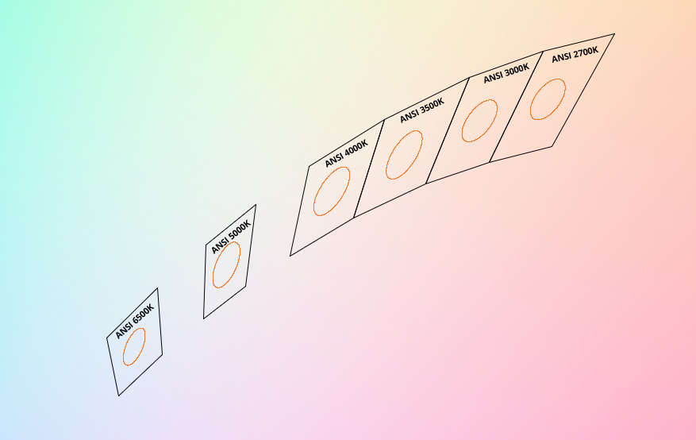

**APS StandardWhite chromaticity bins**

In order to provide highly consistent chromaticities, Yujileds® offers ANSI 3-step bin, and with SimpleBinning technologies based on Yujileds® module, the lighting design is simplified greatly but no compromise on color quality, the equivalent consistency can be expected to 2-step SDCM.

## The first choice for high-performance LED

The revolutionary meaning of Yujileds® APS series LED is not only about its remarkable spectrum quality, but is the balanced achievement of cost, efficacy, maintenance and color rendering. Compared to competitors’ LED, the APS series LED is more friendly for commercialization in different applications.

The APS series LED also supports the unique service/certification by Yujileds® as described below.

|  |  |
| --- | --- |
| **TM-30**  **Specified** | **TM-30 specification**  The most advanced colorimetric for color rendition, widely recognized as the successor of CRI. |
| **TLCI**  **Specified** | **TLCI specification**  Based on the Macbeth ColorCheker, for evaluating the colorimetric quality of the broadcast lighting. |
| **Simple**  **Binning** | **SimpleBinning specification**  Simplify the chromaticity binning with TrueChroma data support to provide the most economical, simple, and practical solution to customers. |
| **PureWhite**  **Binning**  **Options** | **Binning options for Standard or PureWhite**  Besides the industrial standard binning (ANSI 3-step), the optional PureWhite binning can provide balanced and precise white colors. |
| **RoHS**  **Compliance** | **RoHS 2011/65/EU compliance** |
| **CE**  **Compliance** | **CE compliance** |
| **REACH**  **Compliance** | **REACH compliance (Phosphor)** |

# Ordering information

|  |  |  |  |  |
| --- | --- | --- | --- | --- |
| **PART NUMBER** | **PRODUCT CODE** | **CCT** | **CHROMATICITY BINS** | **VOLTAGE BIN** |
| **YJ-APS-1313L-G01-27** | P3220037.27 | 2700K | 27A | V32 |
| **YJ-APS-1313L-G01-30** | P3220037.30 | 3000K | 30A | V32 |
| **YJ-APS-1313L-G01-40** | P3220037.40 | 4000K | 40A | V32 |
| **YJ-APS-1313L-G01-XX** | P3220037.XX | Custom CCT | - | V32 |

# Characteristics

## Electrical-optical characteristics (TA = 25°C, 300mA)

|  |  |  |  |  |  |  |
| --- | --- | --- | --- | --- | --- | --- |
| **PARAMETER** | **SYMBOL** | **VALUE** | | | **UNIT** | **TOLERANCE** |
| **MIN.** | **TYP.** | **MAX.** |
| **Forward voltage** | VF | 32 | - | 39 | V | ±0.05 |
| **Luminous flux** | Ф2700K | 800 | - | 900 | lm | - |
| Ф3000K | 850 | - | 950 |
| Ф4000K | 950 | - | 1050 |
| **Correlated color temperature(1)** | CCT2700K | - | 2700 | - | K | - |
| CCT3000K | - | 3000 | - |
| CCT4000K | - | 4000 | - |
| **Color rendering index** | Ra | 97 | - | - | - | ±1 |
| Ri (i = 1-15) | 90 | - | - | - | - |
| **Fidelity index(2)** | Rf | - | 98 | - | - | - |
| **Gamut index(2)** | Rg | - | 100 | - | - | - |
| **TLCI 2012(3)** | - | - | 99 | - | - | - |
| **Reverse current** | Ir | - | - | 10 | μA | ±0.1 (Vr = 15V) |
| **View angle** | 2θ1/2 | - | 120 | - | Deg | ±5 |

1. Yujileds® promises the chromaticity coordinate tolerance of ±0.0015 (CIE 1931 x,y) based on Yuji standard equipment shall prevail.
2. Defined by the IES TM-30 method, this data is for trial.
3. Defined by the EBU, TLCI is the abbreviation of Television Lighting Consistency Index, this data is for trial.

# Characteristics

## Absolute maximum ratings (TA = 25°C)

|  |  |  |  |
| --- | --- | --- | --- |
| **PARAMETER** | **SYMBOL** | **LIMIT** | **UNIT** |
| **Power Consumption** | PD | 13500 | mW |
| **DC Forward Current (pulsed)(1)** | IFp | 900(2) | mA |
| **DC Forward Current** | IF | 450 | mA |
| **Reverse Voltage** | VR | 60 | V |
| **Junction Temperature** | Tj | 125 | °C |
| **Case Temperature(3)** | Tc | 85 | °C |
| **Operating Temperature** | Topr | -40 ~ +85­ | °C |
| **Storage Temperature** | Tstg | -40 ~ +85 | °C |

1. Pulse width ≤ 0.1ms, duty ≤ 1/10.
2. Theoretical data.
3. See page**Package material and dimension**.

# Chromaticity group and diagram

## Chromaticity bins & coordinates

|  |  |  |  |  |  |  |  |  |
| --- | --- | --- | --- | --- | --- | --- | --- | --- |
| **CCT** | **BIN** | **CIE 1931 COORDINATES** | | | | | | |
| **X** | **Y** | **a** | **b** | **θ** | **SDCM** | **Refer to CCT** |
| **2700K** | 27A | 0.4578 | 0.4101 | 0.00810 | 0.00420 | 49.70 | 3 | 2650 - 2800 K |
| **3000K** | 30A | 0.4338 | 0.4030 | 0.00834 | 0.00408 | 50.22 | 3 | 2950 - 3150 K |
| **4000K** | 40A | 0.3818 | 0.3797 | 0.00939 | 0.00402 | 54.80 | 3 | 3850 - 4150 K |

## CIE 1931 diagram

|  |
| --- |
|  |

# Package material and dimension

## Package layout

All dimensions in mm, tolerance unless mentioned is ±0.1mm.

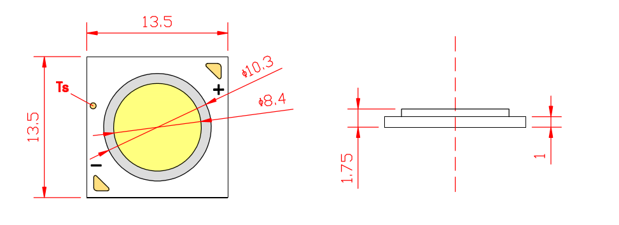

Tc

## Package materials

|  |  |
| --- | --- |
| **ITEM** | **DESCRIPTION** |
| **Die material** | InGaN |
| **Lead frame material** | MCPCB |
| **Encapsulant resin material** | Silicone + Phosphor |

# Characteristic graph

## Typical spectral power distribution (normalized)

All characteristic curves are for reference only and not guaranteed.

|  |
| --- |
|  |

# Characteristic graph

## Forward current

All characteristic curves are for reference only and not guaranteed.

|  |  |
| --- | --- |
| Vs. forward voltage(TA = 25°C) |  |
| Vs. relative luminous flux(TA = 25°C) |  |

# Characteristic graph

## Forward current (continued)

All characteristic curves are for reference only and not guaranteed.

|  |  |
| --- | --- |
| Vs. relative chromaticity shift(3000K, TA = 25°C) |  |
| Vs. absolute chromaticity shift(3000K, TA = 25°C) |  |

# Characteristic graph

## Forward current (continued)

All characteristic curves are for reference only and not guaranteed.

|  |  |
| --- | --- |
| Derating based on case temperature Note: De-rating curves are meant for recommendation only and are not meant to provide guarantees of product stability and longevity. |  |

# Characteristic graph

## Case temperature (Tc)

All characteristic curves are for reference only and not guaranteed.

|  |  |
| --- | --- |
| Vs. forward voltage(IF = 300mA) |  |
| Vs. relative luminous flux(IF = 300mA) |  |

# Characteristic graph

## Case temperature (Tc) (continued)

All characteristic curves are for reference only and not guaranteed

|  |  |
| --- | --- |
| Vs. relative chromaticity shift(3000K, IF = 300mA) |  |

## Spatial distribution (TA = 25°C, IF = 300 mA)

All characteristic curves are for reference only and not guaranteed.

|  |
| --- |
|  |

# About Yujileds

卡通人物

**We help to take care of your light.**

## Our story - Start from the superior stable red LED phosphor.

We started to make LED phosphor materials in 2006. White LEDs were still in very early stage, the industry focused on improving device brightness and efficiency via yellow phosphor very much. No one cared about the light quality. Based on this situation, we took a different approach and focused on red phosphor technology, which is the most important phosphor recipe for high CRI and/or low CCT LEDs, and it made Yuji become a JV partner with Mitsubishi Chemical from 2012.

Today, we are well known for our comprehensive research and full line-up production of LED phosphor from ultra-violet to near-infrared, and we are proud to commit to providing superior stable and efficient phosphors to the worldwide markets.

## Our technology - Focus on LED spectrum innovation.

The industrial structure of both phosphor and LED gives us a unique view to develop our spectrum recipes. Compared to the general LED manufacturers, we have comprehensive information in evaluating the feasibility for both technical and commercial aspects. LED spectrum technology is not only about the quality of white LEDs, but also for different applications which have specialized requirements in lighting.

Yuji is one of the few companies that provide the service of designing or customizing a specific spectrum for clients, our confidence comes from the years of accumulation in focusing on the spectrum technologies and the control of LED phosphor and LED die supply-chain with thousands of successful cases in the past years. Innovating LED technologies and giving them commercial values are our eternal driving forces.

## Our product - Yujileds®, stands for high-performance LED.

The trademark of Yujileds® is the identification of the LED products developed and manufactured by Yuji. We put our understanding of the LED technologies and the standard of our quality control into every LED we make. Regardless of any product series, we pay attention to expressing the high-performance feature and achieving the product value for clients and never compromise in pursuing the true performance.

Furthermore, we also care about every detail of any documentation we prepare for the product because we understand the importance to transmit accurate information to clients. It is even more critical for clients to obtain the truth to decide the solution, rather than just a nominal high-performance.

## Our client - Outstanding game players in different fields.

Clients are our proudest achievements, now over 200 of our clients are the best game players in their fields in more than 33 countries. We regard the clients’ successes as our biggest accomplishments and appreciate their contribution in different fields, clients use our LEDs not just for simple lighting, but to design the lighting for plants, cameras, sensors, health, circadian rhythm, aminals, and other industries that we have never imagined that our technologies can be utilized, that makes our work so meaningful.

## Our service - Professional supporting team.

There is a group of people in Yuji passionate about creating maximum value for our clients. We have accumulated experience in different projects. Currently, the company gathers more than 30 experts from various fields of semiconductor, chemistry, optics, photoelectricity, circuitry, materials and color science.

Our sales team is well trained in deep LED technologies and has skilled global communication experience. Not just for sales, our team is more like a specialized consultancy to help every client succeed in different projects, and we do not only provide professional business service, but also support in the supply chain, logistics, marketing and technical discussions.

## Contact us - We look forward to providing our efficient service for you.

**LED website:** [**www.yujiintl.com**](http://www.yujiintl.com)

Find Yujileds® high-performance LEDs, read our insights into a variety of advanced technologies and applications.

Contact: [info@yujigroup.com](mailto:info@yujigroup.com)

**LED lighting website:** [**www.yujilighting.com**](http://www.yujilighting.com)

Find our state-of-art LED lamps and luminaires designed for improving the lighting experience with the vision of illuminating the future.

Contact: [lighting@yujigroup.com](mailto:lighting@yujigroup.com)

**Online shop:** [**store.yujiintl.com**](http://store.yujiintl.com)

Shop your favorite Yuji Lighting product with rapid and professional service.

Contact: [webstore@yujigroup.com](mailto:webstore@yujigroup.com)